**Module 8) Bootstrap Basic & Advanced**

1. **What are the advantages of Bootstrap?**
2. **Top 10 Advantages of Bootstrap for Web Development.**

**1.Wasy initiation**

**2.Responsiveness**

**3.Highly Customizable**

**4.Extremely user-centric**

**5.Top-notch support**

**6.Cross-browser compatibility**

**7.JavaScript plugins to your rescue**

**8.Far-reaching popularity**

**9.Ample documentation**

**10.updates at the doorstep**

1. **What is a Bootstrap Container, and how does it work?**

**Ans – in Bootstrap, container is used to set the content`s margins**

**Dealing with the responsive behaviors of your layout. It**

**Contains the row elements and the row elements are the**

**Container of columns (know as grid system). The container**

**Class is used to create boxed content.**

**Example :-**

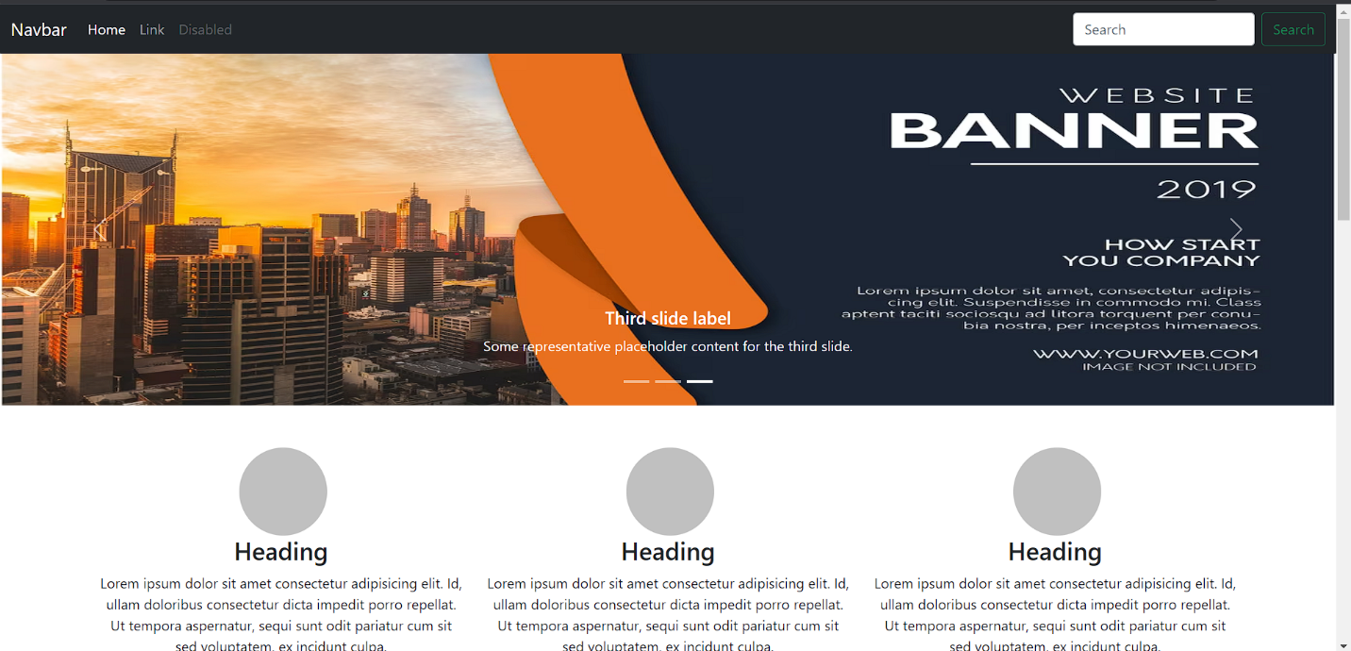

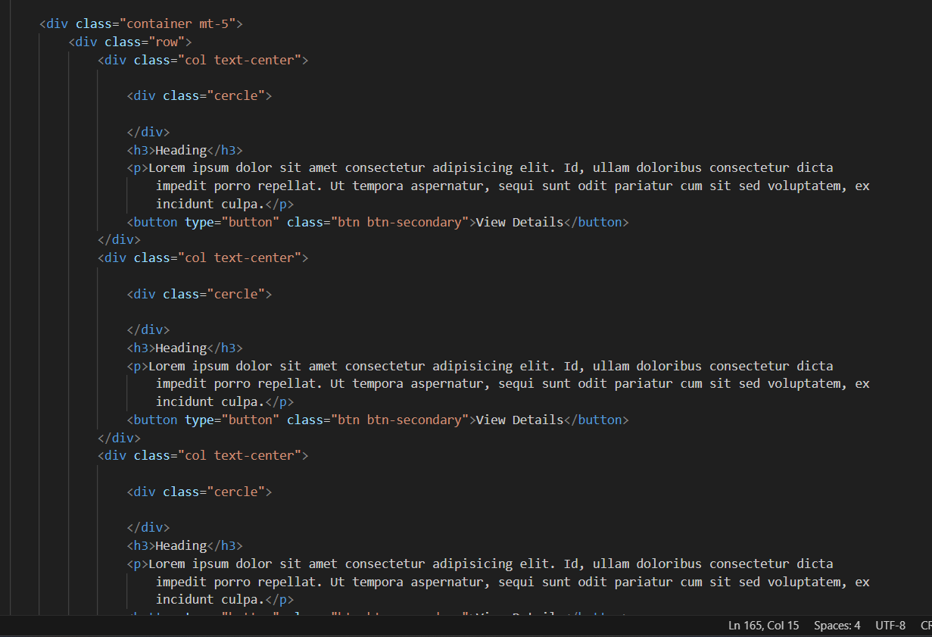

**3.What are the default Bootstrap text settings?**

**Ans - Bootstrap 4 uses a default font-size of 16px, and its line-height is**

**1.5. the default font-family is “Helvetica Neue”, Helvetica, Arial,**

**Sans-serif. In addition, all <p> elements have margin-top: 0 and**

**Margin-bottom: 1 rem (16px by default).**

**4. What do you know about the Bootstrap Grid System?**

**Ans – Bootstraps grid system uses a series of containers, rows, and**

**Columns to layout and align content. It`s built with flexbox and**

**Is fully responsive. Below is an example and an in-depth look**

**At how the grid comes together. New to or unfamiliar with**

**Flexbox.**

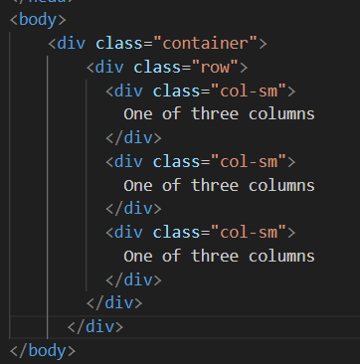

**4. What is the difference between Bootstrap 4 and Bootstrap 5**

**Ans – Bootstrap 4 has five levels: xs, sm, md, lg, and xl. Bootstrap 5**

**Has six levels: xs, sm, lg, xl, and xxl. Bootstrap 4 includes jquery**

**And all associated plug-ins. Jquery has been deleted and replaced**

**With vanilla JS and several functional plug-ins in Bootstrap 5.**

**5**. What is a Button Group, and what is the class for a basic Button Group?

**Ans** – button Groups in Bootstrap is a class of name btn-group which is

**Used to creat a series of buttons in groups (without spaces) Ver**-

**Tically or horizontally**. Syntax: This is the basic syntax of the button

**Group class where each button has own class of “btn”**.

6. **How can you use Bootstrap to make thumbnails?**

**Ans – Add an <a> tag with the class of thumbnail around an image.**

**This adds four pixels of padding and a gray border.**

**On hover, an animated glow outline the image.** 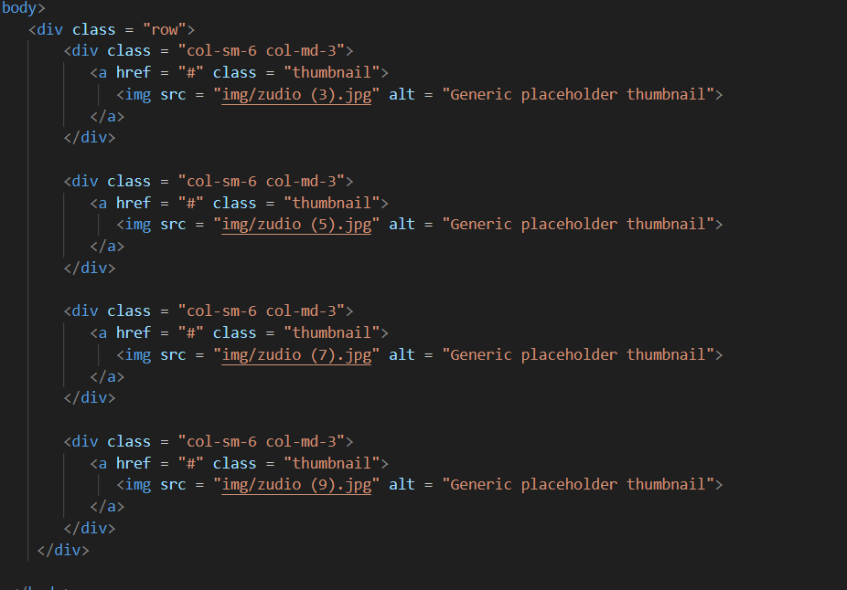

**7. In Bootstrap 4, what is flexbox?**

**Ans – Flexbox The biggest difference between Bootstrap3 an**

**Bootstrap4 now uses flexbox, instead of floats, to handle**

**The layout. The flexible Box Layout Module, makes it easier**

**To design flexible responsive layout structure without using**

**Float or positioning.**

**8. How can one create an alert in Bootstrap?**

**Ans – Bootstrap provides an easy way to create predefined alert**

**Messages.**

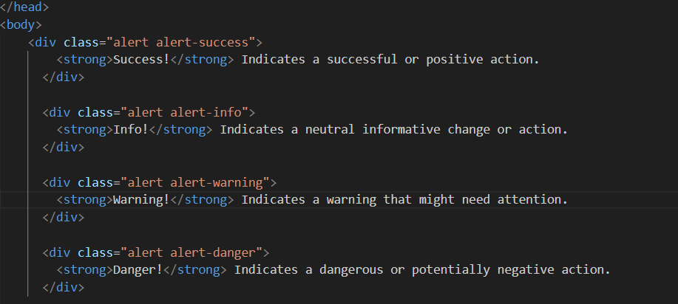

**9. What is a bootstrap card and how would you create one?**

**Ans- A card is a flexible and extensible content container. It includes**

**Options for headers and footers, a wide variety of content, contextual**

**Background colors, and powerful display options. If you`re familiar with**

**Bootstrap 3, cards replace our old panels, wells, and thumbnails.**

